NOOR UL AIN
FA25-BMD-144
LIST TASKS
M1
INPUT:
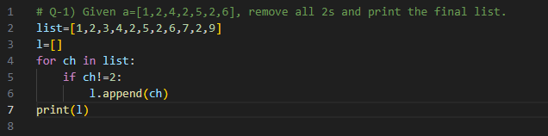
OUTPUT:
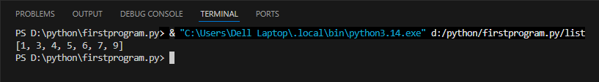
M2
INPUT:
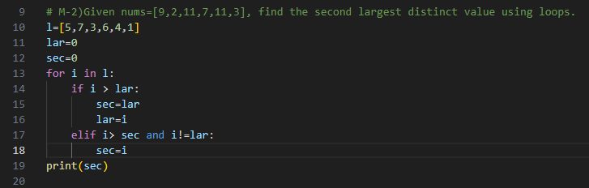
OUTPUT:


M3
INPUT:
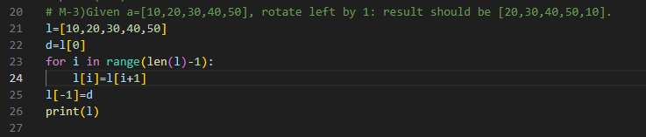
OUTPUT:
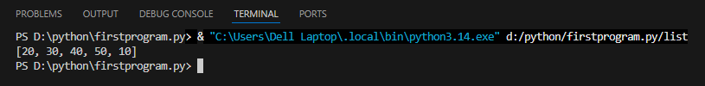
M4
INPUT:
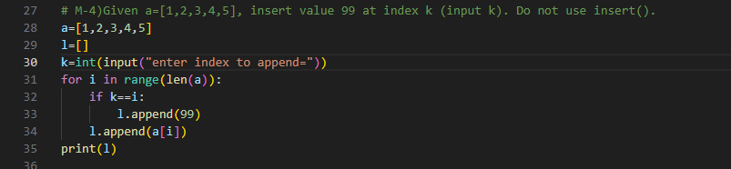
Output:
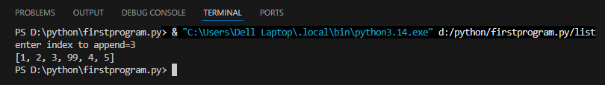
M5
INPUT:

